Variable characteristics

## Age

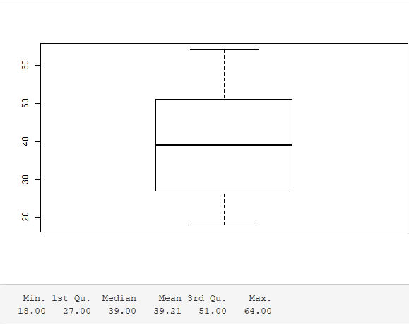

#### Histogram

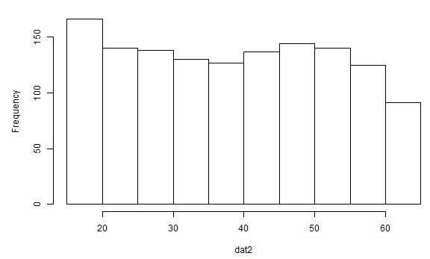

## BMI

#### 

#### Histogram

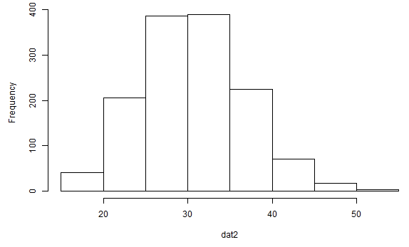

## Children

#### 

#### Histogram

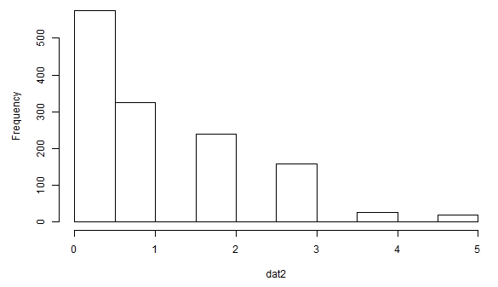

## Charges

#### Histogram

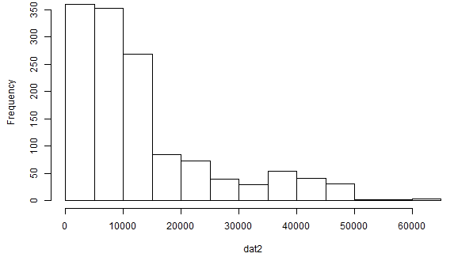

## Sex

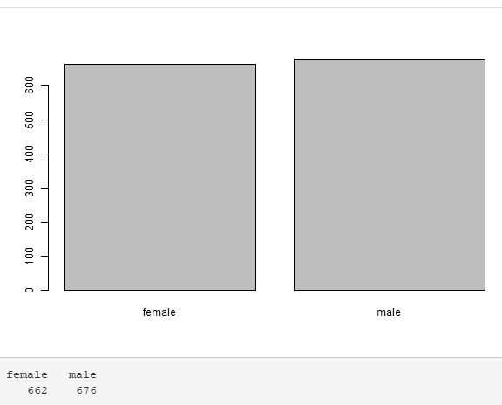

## Smoker

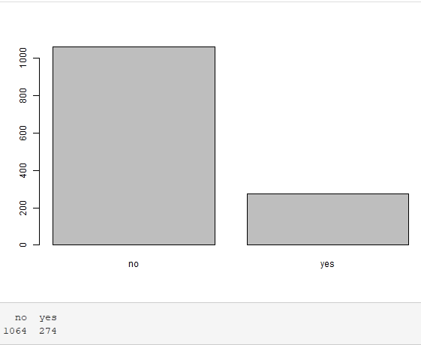

## Region

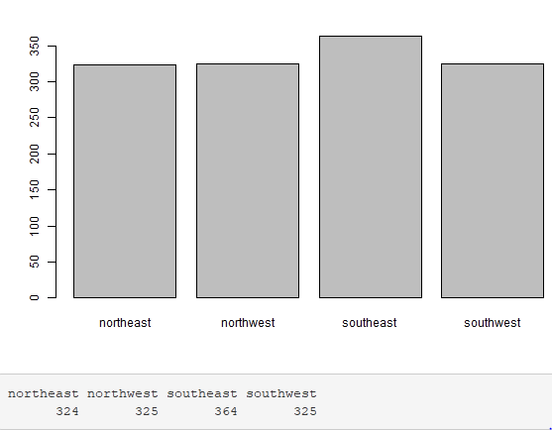

Relationships between variables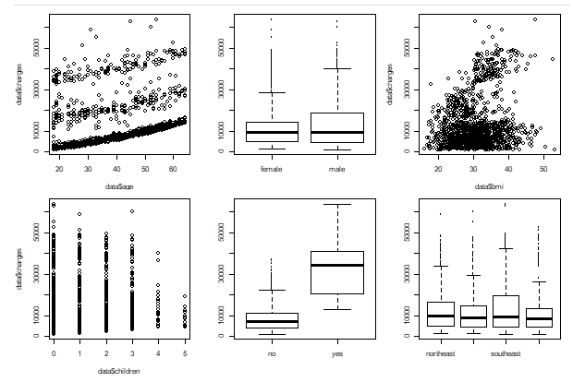

Conslusions:

-Charges increase with age.

-On average, women's charges are the same as men's.

-for 1-3 children the charges are similar, the more children (4-5) the lower the charges

-smokers spend significantly more than non-smokers

-in each region the levies shall be levied

Correlations between variables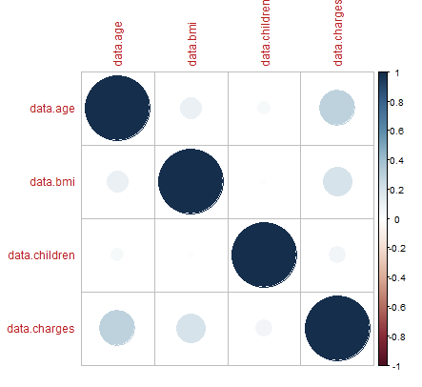

-The most correlated are age and chargres variables.

-Then charges and bmi.

-Then children and charges.

-There is no negative correlation.